
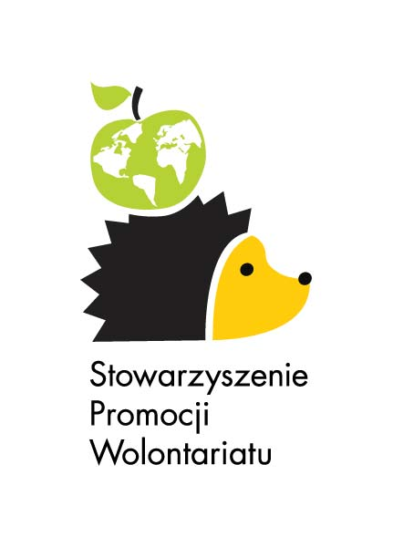

Volunteer Data

Name of the volunteer :

2012-PL-97 Foundation “Helping Hand”
2010-PL-78 Sociotherapy Centre for Youth "Jedrus”
2010-PL-89 Education, Rehabilitation and Welfare Centre "Helenow"

Name and address
First name |  |  |  |  |  |  | Photo
Last name
Date of birth
Place of birth
Gender | Female Male
Nationality
Country of legal residence if different
Street address
Postcode |  |  |  | Town
District or region |  |  |  | Country
E-mail
Telephone | prefix | number | Fax |  |  | prefix |  | number
Mobile phone

Background information

What is the highest level of education you have completed (check one box only) | primary education  secondary education  vocational training  higher education
Current situation  (1 box only) | working  unemployed  long-term unemployed (> 6 months)  studying  training  other, specify……

What are your language skills? | Language | Level
Please use the following codes:
1 = mother tongue, 2 = fluent,
3 = good, 4 = basic.

Have you previously participated in voluntary service, community activities, or youth organisations? (check as many as apply.) | no  yes, short or long term voluntary service  yes, community activities  yes, youth organisations or other organisations

Describe the organizations, movements, service programs and other projects in which you have participated

What volunteer work do you do or have you done? (If you do or did, indicate what)

Describe the place where you live (town, city, village; is it an urban, rural, industrial area?; where is located?; population?; unemployment rate?; ) Describe your cultural, geographical and socio-economic background.

Father’s name |  | Profession
Mother’s name |  | Profession

Do you have brothers or sisters? | no yes, how many: …….. brothers  ……... sisters

Emergency contact
Please provide contact details of a person who can be contacted in case of an emergency.
Family name (Mr/Ms) |  | First name
Street address
Postcode |  | City
Region |  | Country
Telephone |  | Email

Motivation
Please describe why you want to participate in the European Voluntary Service, including your expectations concerning volunteering.

What relevant skills would you like the hosting project to know? What kinds of activities would you like to contribute to a project?

Describe your future plans with reference to studies or occupation

Describe your previous international or intercultural experience (e .g. youth exchange, studies or work abroad)

Why did you choose Poland?
Why did you choose this project?

Do you have special needs that would need to be taken into account: | dietary needs, if yes, specify …………..  problems of mobility, if yes, specify …………..  health care, if yes, specify …………..  any allergies, if yes, specify …………..  any other, if yes, specify …………..

Do you already have a sending organisation? | yes  Name: ProAtlântico – Associação Juvenil  EI number: 2010-PT-28  Contact person: Nuno Chaves  E-mail: sveenvio@proatlantico.com  Phone: 00351 21 4218417  no

BEFORE YOU DECIDE FOR THE PROJECT…

Dear Candidate,

Below you will find a list of things which you should consider before deciding for our SOCIAL PROJECT. It is not to scare you but to make you aware how the project will look like and to reduce possibility of your disappointment after arrival☺

1. Are you ready to eat traditional Polish food from canteens and adjust to their meal times for 10 months?
There is no possibility to get food allowance and cook you instead of canteen meals.

2. Are you ready to live in a shared room with a person with different habits and different cultural background?
There is no possibility of changing your roommate.

3. Are you ready for simple conditions and living in your host organization?
There is no possibility of changing your accommodation once you are in the project.

4. Are you ready for limited access to the internet e.g. slow connection or access only in a school computer room?
Providing internet in volunteers’ place is not obligatory for the host organization, however we do our best to ensure basic connection to everyone. Volunteers are also welcome to use internet in SPW’s office.

5. Do you have enough motivation and sense of responsibility to work with people with fewer opportunities (disabled children or children with learning difficulties or adult people with intellectual disability) for 10 months?
This kind of work is demanding and sometimes monotonous. You will need a lot of patience but also ability to work independently and a dose of own initiative.

6. Are you willing to solve problems through discussion and compromises?
Flexibility and empathy from both sides is crucial to create conditions satisfying everyone.

6. Are you aware of the fact that EVS is not a professional training and volunteer’s role is to support the workers, make individual relationships with people under your charge and add intercultural dimension to activities of the host organization?
Too high expectations from volunteer’s side end with his/her disappointment.

If you answered YES to the questions above, you will enjoy the project and gain a lot of various experiences during your stay in Poland.

All the best,

Sylwia Jedra
EVS Coordinator

